**Bug 2 Screenshot log for Hypotheses**

**Hypothesis 1**

Breakpoint set in RecordServicesCTL Line 39

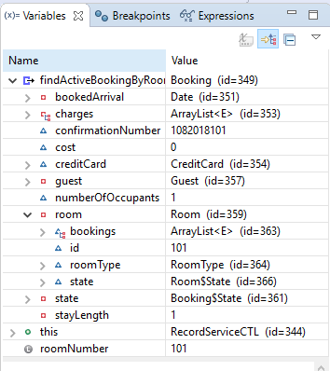

**Hypothesis 2**

Breakpoint set in Hotel Line 64

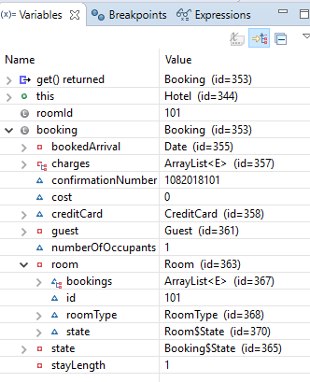

**Hypothesis 3**

Breakpoint set in CheckoutCTL Line 39